Syntax directed translation examples

Bottom up

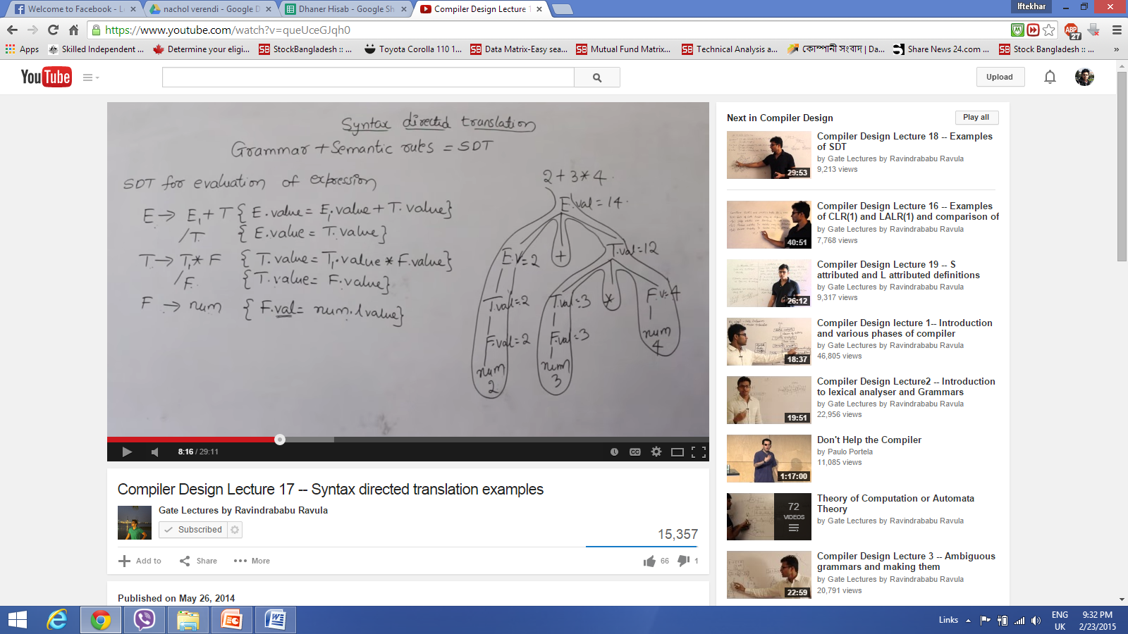

Above example 2, 3,4 are lexical values, every variables are having some attributes

Right hand side the semantic rules are applied and performs some semantic actions

Top down

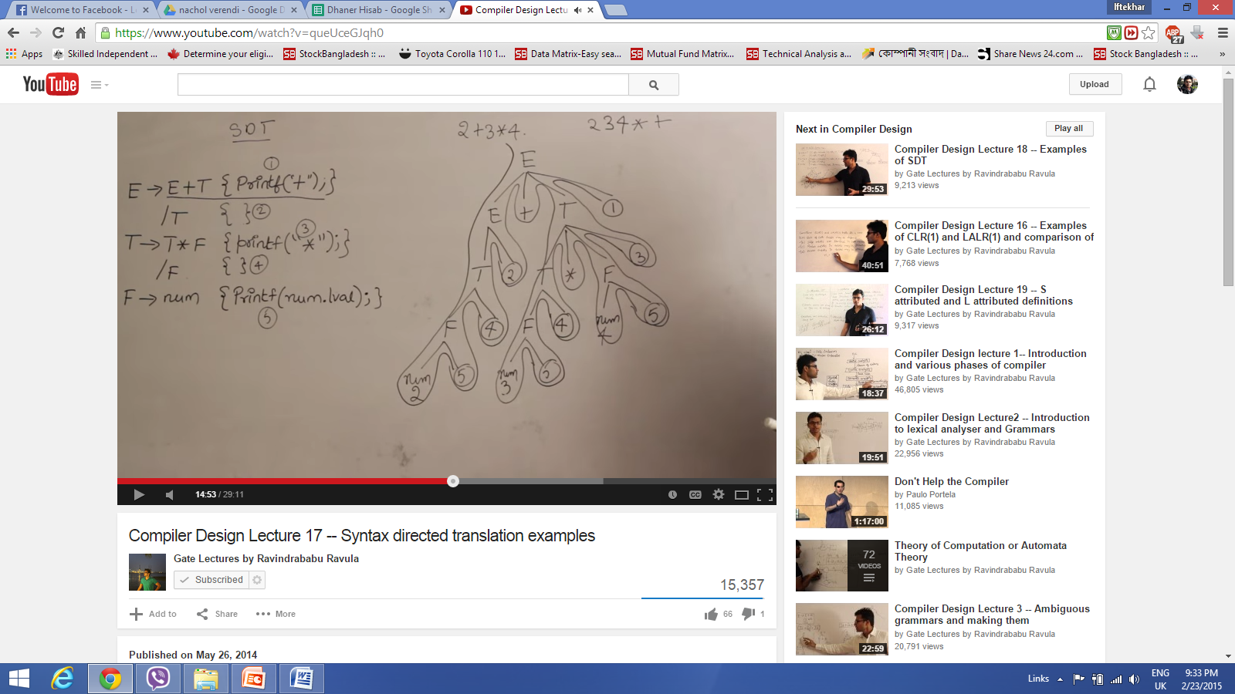

Bottom Up

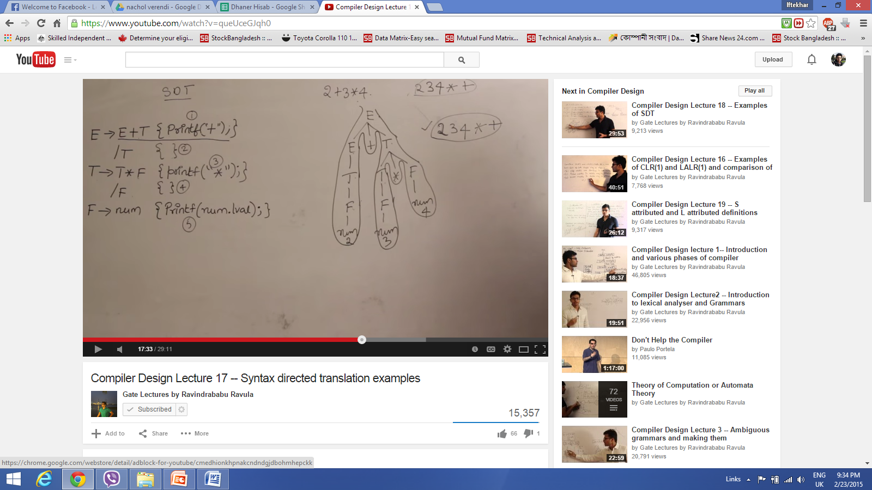

Top down and bottom up both scenarios it generates the same output

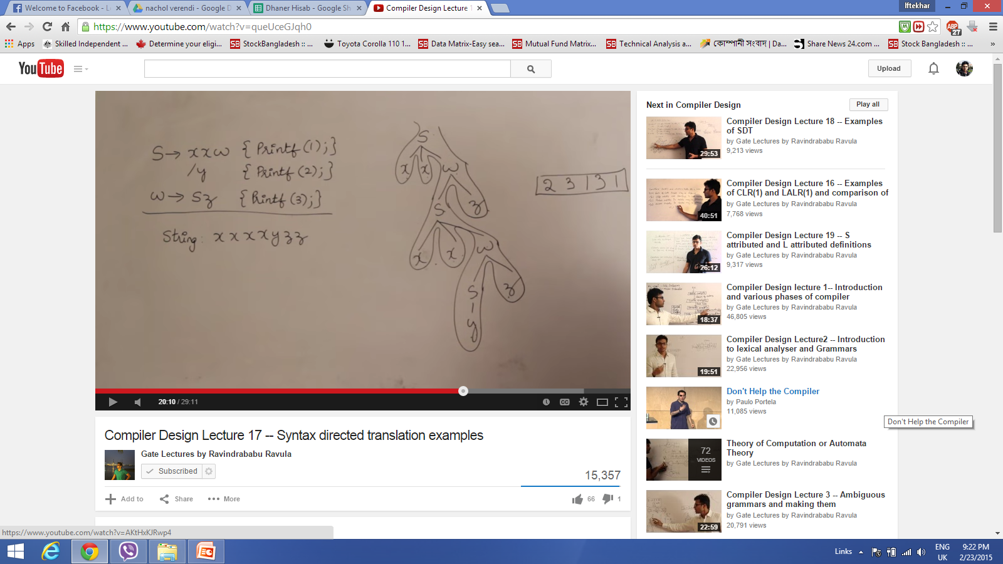

Below minus is right associative, minus have higher precedence than star sign in the following example

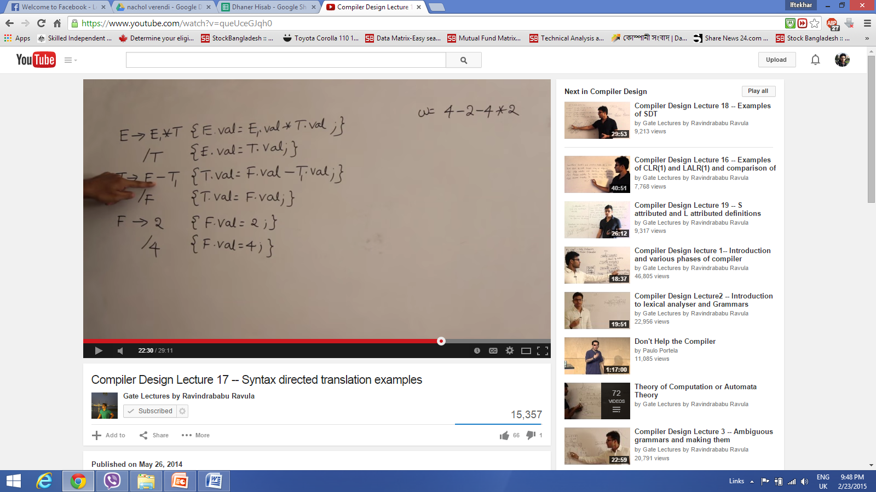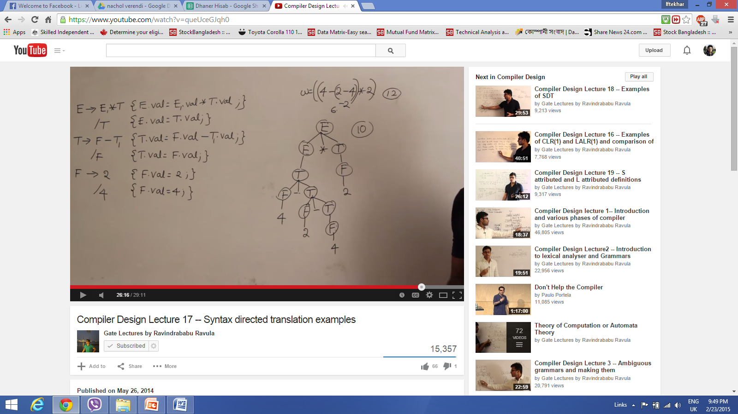

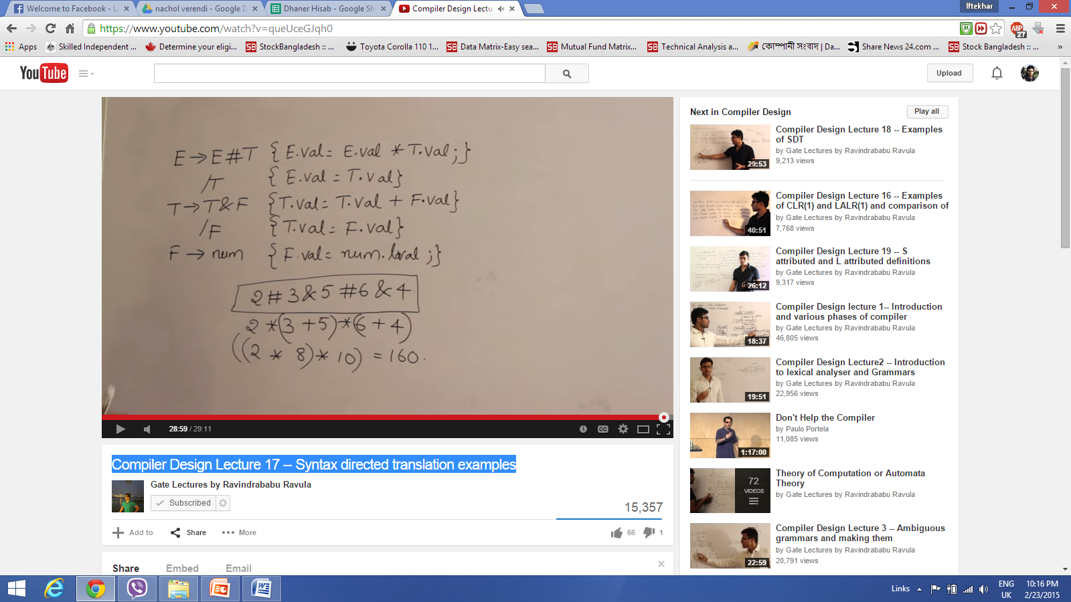

concrete parse tree: Usual syntax tree is a concrete parse tree

Abstract Parse Tree: this is another form for intermediate code generation

Annotated parse Tree/

